|  |
| --- |
| SOFTWARE ENGINEERING |
| THE LAYERS MANAGEMENT SYSTEM PROJECT REPORT FOR MRS. MUDDE KAMANZI’S POULTRY FARM |
| Software Report version 1.0 |
|  |
| **Group 0** |
| **1/1/2017** |

|  |
| --- |
| Mrs. Mudde manages a poultry farm for rearing layer chicken and in this report is documented the information about her project and the intended software engineering solution action the engineering team has taken to give her software solution for her project. |

**Preface**

This report was written based on information collected from **Mrs. Mudde Kamanzi** through interviews and analytical data collection from the poultry farm. It is all part of the initiative to engineer new layers management software for the layers’ project which is to support her project activities.

Furthermore, it is combined with a complete statement of requirements document and architectural as well as component design specification all of which have been generated basing on the discussion meetings done by the software engineering team which include the following members:

|  |  |  |  |
| --- | --- | --- | --- |
| FULL NAME | REGISTRATION NO. | STUDENT NO. | EMAIL ADDRESS |
| AGABA DAVIS | 16/U/2812/PS | 216009915 | davisag67@gmail.com |
| ANKUNDA DOROTHY | 16/U/3483/PS | 216014145 | ankdorothy@gmail.com |
| KOBUSINGE ALICE | 11/U/11462/PS | 211005867 | kobalice@gmail.com |
| KYESWA LUTIMBA IVAN | 16/U/512 | 216001516 | ivocsceduc@gmail.com |

**Acknowledgement**

This report would not be a success hadn’t it been for the support rendered by all the software design team members who have tirelessly rendered there time and resource in contributing towards the project.

We give special thanks to **Mrs. Mudde Kamanzi’s** farm manager, **Mr. Kamya Moses** for her time and contribution in giving us information about the poultry farm and enduring through those long hours of interviewing. Gratitude goes to **Agaba Davis** and **Ankunda Dorothy** who where our chief interviewers. In a special way we also thank **Kobusinge Alice** for her wonderful contributions during meetings. The manager always had something good to add to everything. This document has been a group effort and all members have contributed to its success.

Contents

[1. PROJECT DESCRIPTION 1](#_Toc494703214)

[2. FACTS COLLECTED AND MANAGEMENT 10](#_Toc494703215)

[3. REQUIREMENTS SPECIFICATION 13](#_Toc494703216)

[A. USER REQUIREMENTS 13](#_Toc494703217)

[B. SYSTEMS REQUIREMENTS 13](#_Toc494703218)

[4. USE CASE DIAGRAMS 15](#_Toc494703219)

[5. USE CASE DESCRIPTION 16](#_Toc494703220)

[6. THE ACTIVITY DIAGRAMS 19](#_Toc494703221)

[8. USER INTERFACES 23](#_Toc494703222)

[6. COMPONENT DESIGN 28](#_Toc494703223)

[8. SYSTEM ARCHITECTURE 29](#_Toc494703224)

[7. FACTS FINDING METHODS 30](#_Toc494703225)

[a) QUESTIONNAIRE 30](#_Toc494703226)

[8. APPENDIX 31](#_Toc494703227)

[Table of acronyms 31](#_Toc494703228)

[Figure 1 the chicken house 1](#_Toc494703229)

[Figure 2 Manager holding books of records. 2](#_Toc494703230)

[Figure 3 Agaba Davis on the farm. 3](#_Toc494703231)

[Figure 4 Growers 4](#_Toc494703232)

[Figure 5 Layers in there early egg production stage 4](#_Toc494703233)

[Figure 6 Layers in their late egg production stage 5](#_Toc494703234)

[Figure 7 Stock of layers mash. 6](#_Toc494703235)

[Figure 8 Record that demonstrate weekly account management of current system 7](#_Toc494703236)

[Figure 9 Record at Closer of Batch/stock 8](#_Toc494703237)

[Figure 10 one of the receipts obtained from the manger. 9](#_Toc494703238)

[Figure 11 System’s use case diagram 15](file:///C:/Users/Kyeswa/Desktop/SE%20Group/Final%20Report.docx" \l "_Toc494703239)

[Figure 12 signing up activities 19](#_Toc494703240)

[Figure 13 Login in activities 20](file:///C:/Users/Kyeswa/Desktop/SE%20Group/Final%20Report.docx" \l "_Toc494703241)

[Figure 14 taking records activities 21](#_Toc494703242)

[Figure 15 Viewing activities 21](file:///C:/Users/Kyeswa/Desktop/SE%20Group/Final%20Report.docx" \l "_Toc494703243)

[Figure 16 scheduling activity 22](#_Toc494703244)

[Figure 17 login (left) and sign up (right) pages 23](#_Toc494703245)

[Figure 18 Stock registration (left) and main (right) pages 24](#_Toc494703246)

[Figure 19 the Expenses (left) and Sales (right) record entry pages. 25](#_Toc494703247)

[Figure 20 the death/loss (left) and Sales record (right) entry forms 26](#_Toc494703248)

[Figure 21 the Generates record view report page 27](#_Toc494703249)

[Figure 22 architectural design 29](#_Toc494703250)

## PROJECT DESCRIPTION

**Mrs. Mudde’s Farm**

**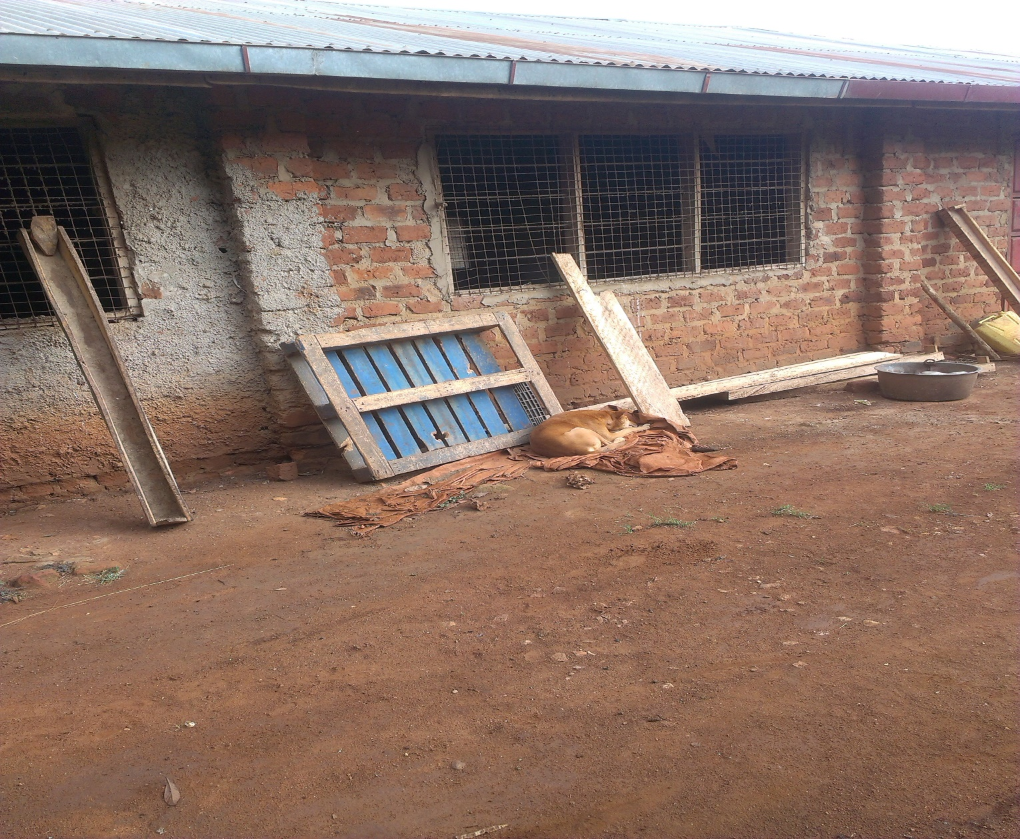**

Figure 1 the chicken house

Mr. Kamya Moses is the manager of Mrs. Mudde’s Farm which is located in Bulindo Village, Kira Town Council parish, Kyadondo County, Wakiso district.

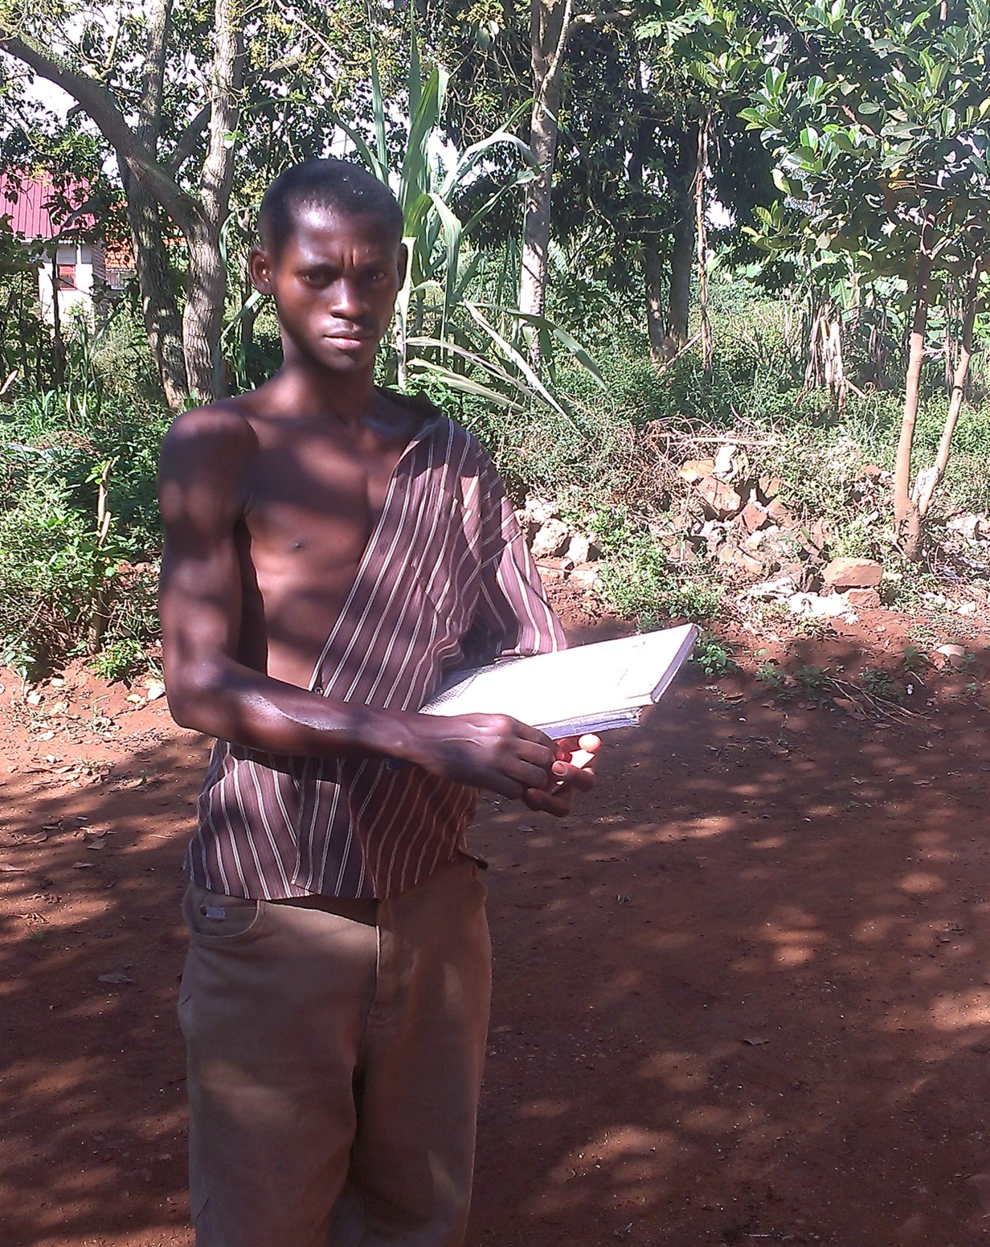

Figure 2 Manager holding books of records.

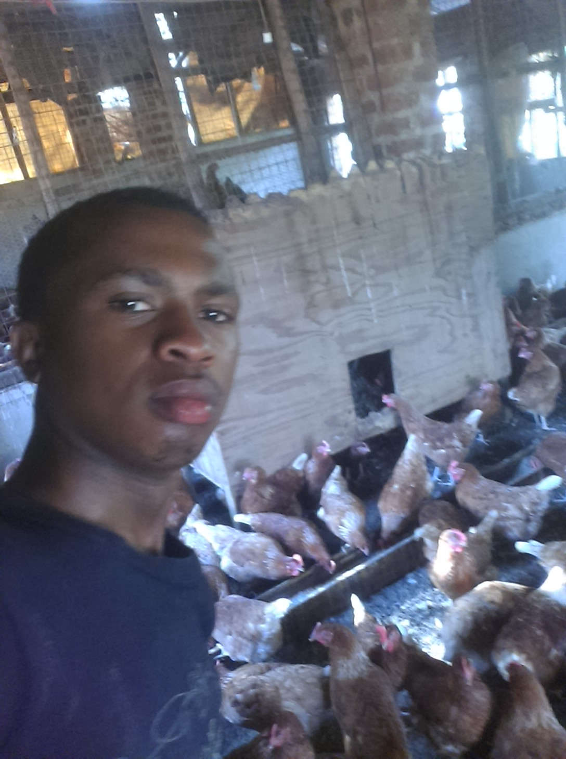

Figure 3 Agaba Davis on the farm.

Mrs. Mudde has poultry, and other animals like cows, goats and pigs in her farm. We interviewed the manager of this farm and these were our observations;

Mrs. Mudde employees 3 workers and each worker are paid **Ugx** **80,000** per month to work in her farm amongst who is the manager who she pays **Ugx** **150, 000** monthly.

According to the information obtained from the manager, poultry is the major source of the income in Mrs. Mode’s Farm. They have **600 birds** and they specialized in keeping layers type of birds in **4** batches.**200 birds** are at growers’ stage **(approx. 2month old)**, **200birds** in its early layers stage **(5 to 6 month)** and other **200 birds** are at layers stage.

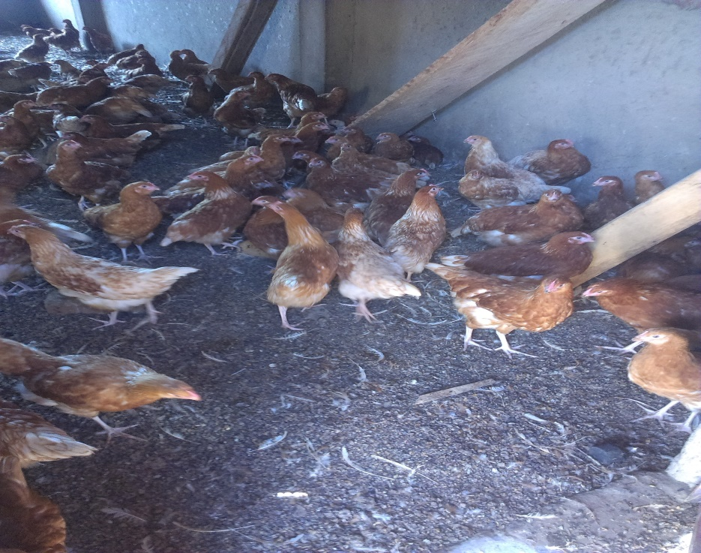

Figure 4 Growers

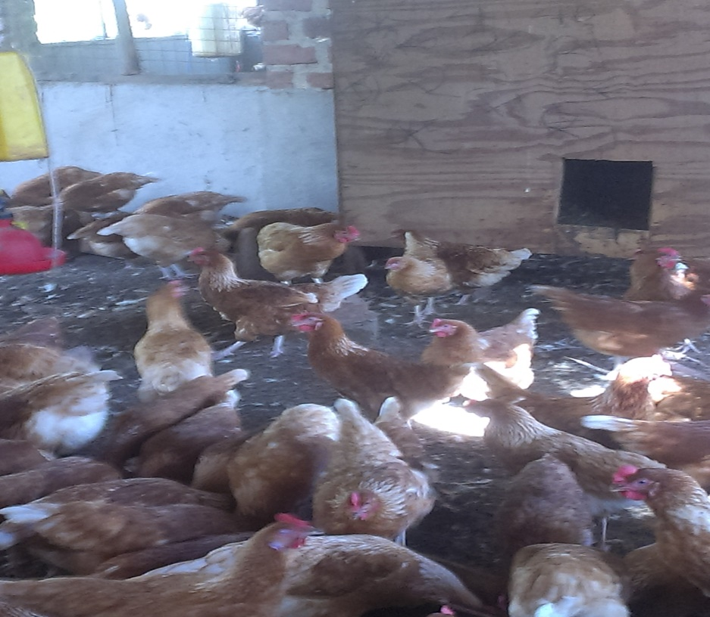

Figure 5 Layers in there early egg production stage

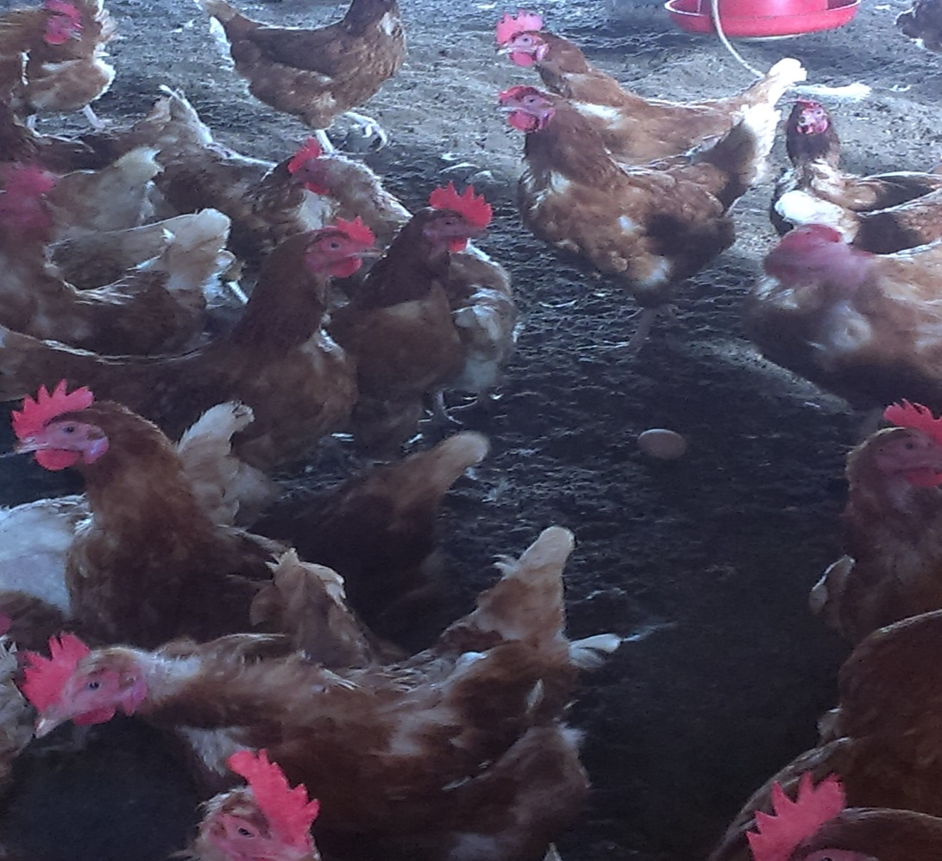

Figure 6 Layers in their late egg production stage

These birds are fed on different kinds of feeds, growers feed on grower’s mash until they reach 20% of the egg production. Layers feed on layers mash until they are sold off and he stocks feeds every week. He however separates his poultry for easy identification in these batches. These feeds are kept in the store where he separates them accordingly.

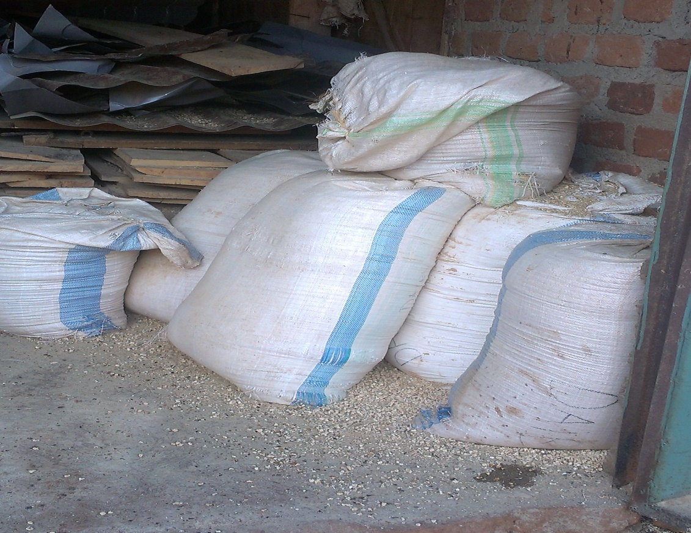

Figure 7 Stock of layers mash.

The profits obtained from each laying batch are kept differently and then reports them to the manager after week.

According to the manager, he keeps record in the book of each stock/batch differently and he reports to owner every week after balancing the records. The records kept include expenses, production, death/loss, receipts, and he starts recording from the day he buys new stock until they are off layers and every stock until they are off layers and every Stock has its own records.

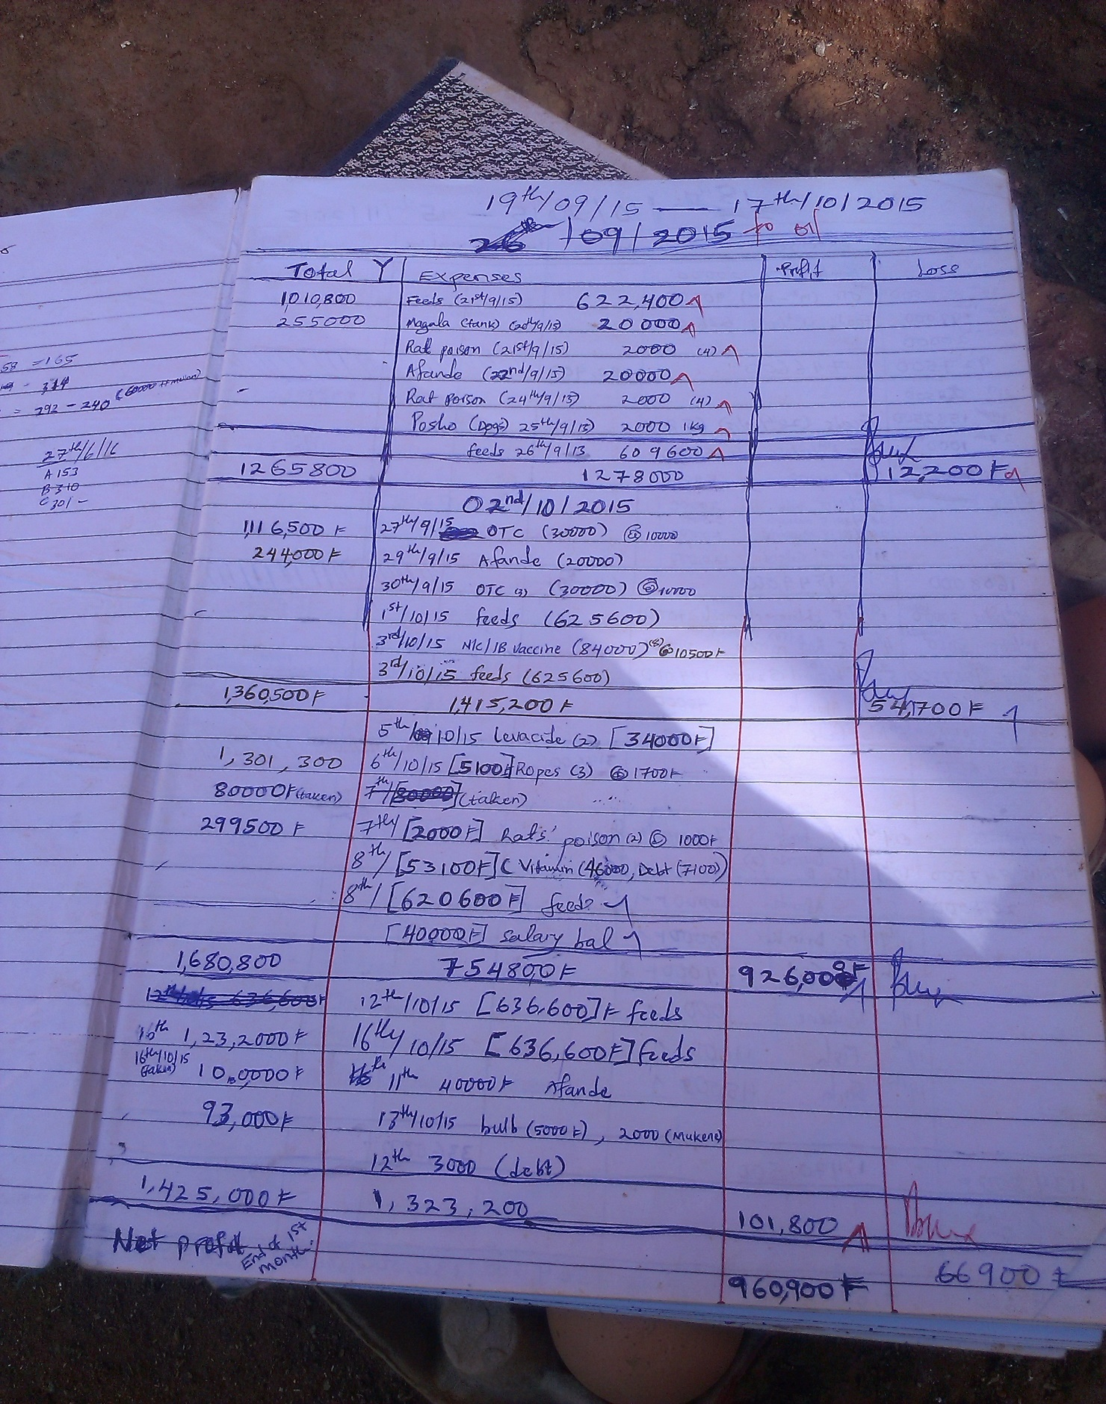

Figure 8 Record that demonstrate weekly account management of current system

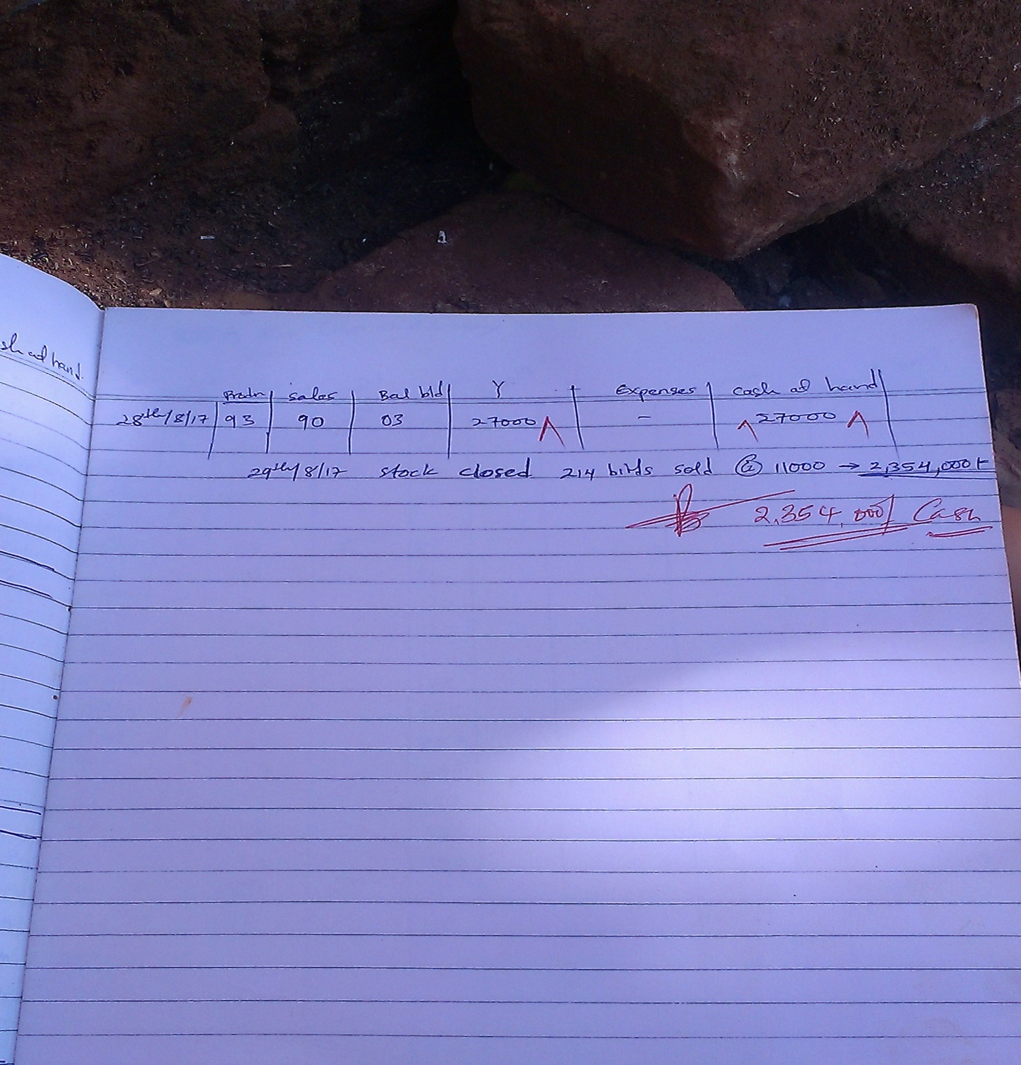

Figure 9 Record at Closer of Batch/stock

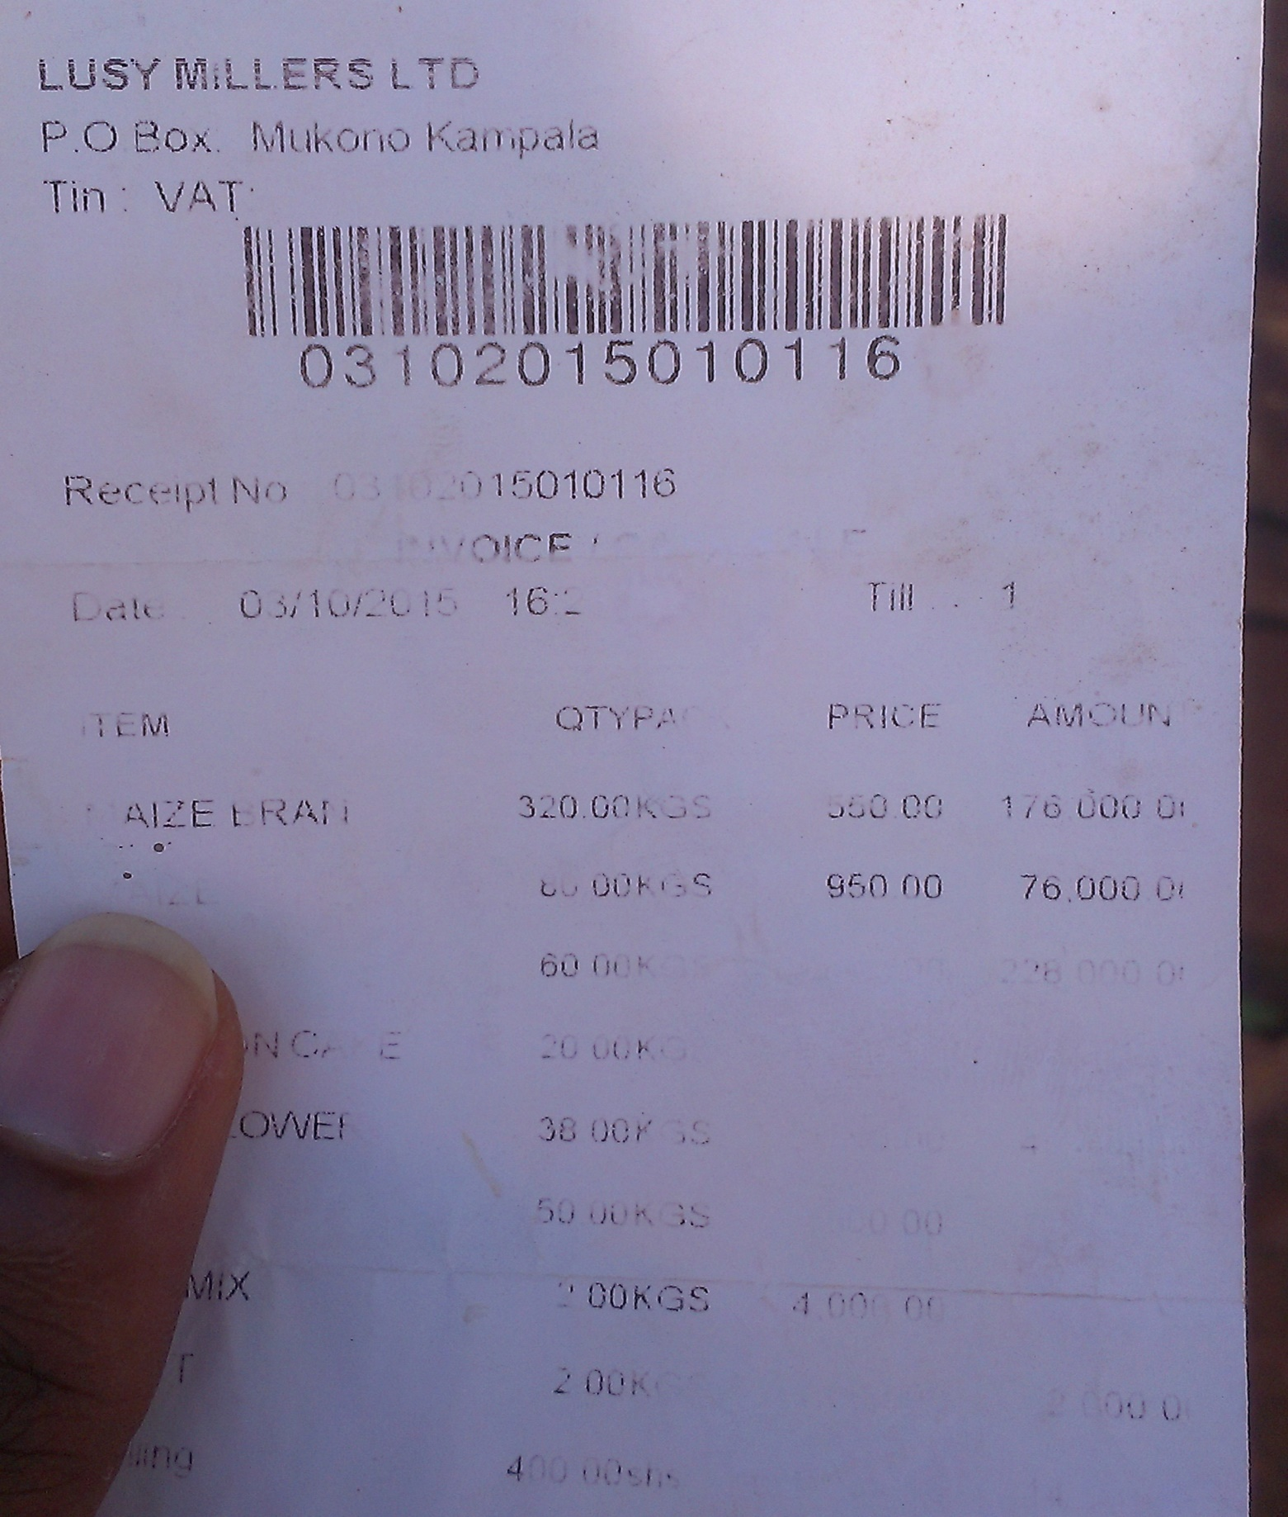

Figure 10 one of the receipts obtained from the manger.

## FACTS COLLECTED AND MANAGEMENT

This is a table that represents the facts we collected from Mr. Mudes’ farm.

Table 1 Facts Analysis table

|  |  |  |  |
| --- | --- | --- | --- |
| **Index** | **Reference** | **Results** | **Conclusion** |
| **FCM: 1** | **QN:1** | The manager said that they keep layers. | We are going to focus on layers only |
| **FCM: 2** | **QN:2** | The manager said they kept had 600 birds. | These are many birds and so must need proper records. |
| **FCM: 3** | **QN:3** | The manager said that he separates the birds into chicks, growers and layers and considers each new batch of chicks as a new Stock up to when they are sold off as off-layers. | This stock is monitored all through the growth process. A new stock means new chicks. |
| **FCM: 4** | **QN:4** | I consider the level of growth of the birds because chicks are fed on starter feed, growers on growers’ mash and I feed the laying fowl on layers’ mash. | These chicken feeds are unique to each batch and so growth of birds determines the type of feed given. |
| **FCM: 5** | **QN:5** | Chicks start feeding on starter feed as early as 3 days of age until they grow up to 6 weeks. At this stage they are growers and so they start on growers’ mash until they grow up to 12 weeks. Here most of them would have started laying some eggs and so I start feeding them on layers’ mash. | This growth times are a good description of how layers grow and how they are fed. |
| **FCM: 6** | **QN:6** | The manager said that the birds in their chick stage are bought from Biyinzikka managers Group because the chicks are cheap where each chick is 3000shs. | Chick cost is one of the primary expenses. Buying chicks is and activity on done on the farm. |
| **FCM: 7** | **QN:7** | The manager said, “We are 3 employees in charge of the daily activities like cleaning, feeding, picking eggs and periodic consultant who visit the farm once in a while to evaluate and give the necessary advice but am the manager”. | There is an organization structure at the farm and an involvement of a work force with well-defined roles and salary. |
| **FCM: 8** | **QN:8** | The manager said they incurs the following expenses;   * Transport * Charcoal * Feeds, * Electricity * labor * water * Medicine * Vaccines * Other petty expenses like airtime, casual labor. | These items are potential reasons for expenditure and so have to be taken note of. |
| **FCM: 9** | **QN:9** | We sell mostly eggs, off-layers and sometimes manure from the chicken beddings. | These are the source of revenue. |
| **FCM: 10** | **QN:10** | Yes, we also have other animals but layers are the main source of income. | The layers are the major source of income for the manager and so need to be cautious about its success |
| **FCM: 11** | **QN:11** | The manager said they keep records | The system must help in record keeping. |
| **FCM: 12** | **QN:11 a)** | The manager said that he keeps the records herself though he is answerable to the owner. | The record keeping responsibility is for the manager. |
| **FCM: 13** | **QN:11b)** | The manager said that he keeps records about;   * Purchases such as chick bought, feeds, payment of workers, vaccines, medicine, electricity and water bills. * The number of eggs obtained daily. * The date on which chicks are bought. * Vaccinations made * Number of birds on the farm | All these things must be represented in records keeping. |
| **FCM: 14** | **QN:11c)** | * It helps me to know the production performance. * I can know the growth of birds. * It helps me to determine when to bring new stock of birds. * I can evaluate the extent of vaccination. * I can know how the number of birds that remain on the farm when some die or are sold. * It becomes easy for me to balance accounts. * Calculate profits. * Giving accountability to the owner | Records must be managed in search a way that they achieve all these benefits for the manager. This can serve as first priority user requirements |
| **FCM: 15** | **QN:11d)** | I do so whenever a recordable event happens. | The records have to be taken immediately at all times. |
| **FCM: 16** | **QN: 11e)** | I lock up the book of records in a drawer after taking records so that I don’t lose it and so that no one can tamper with it. | The managers’ records are very confidential. They must be secured. |
| **FCM: 17** | **QN:11f)** | I would fail to manage the finances and would not be able to give proper accountability. | Records are very important for this farm so they must always be available. A database can help |
| **FCM: 18** | **QN:13** | Sometimes the eggs break.  We also loose birds due to disease outbreak, theft and predators. | These conditions cause a need for editing records. |
| **FCM: 19** | **QN:14** | I do weekly totaling of income and expenditure for every batch and at the closer of every Stock, I add up these weekly total of income and expenditure then by subtracting expenditure from income, I calculate the profit from that Stock | This calculation must be adopted to calculate profits. |
| **FCM: 20** | **QN:15** | I would rather use a phone because it is cheapest amongst the options. | Mobile application best suites this case. |

## REQUIREMENTS SPECIFICATION

Following the facts collected and analyzed above we resolved to make a system which satisfies the following requirements:

### USER REQUIREMENTS

1. The **LMS** should enable the manager to take all poultry records and keep them in an online database. **(Ref: FCM: 11, FCM: 12).**
2. The **LMS** must separately handle the records of each stock through the initialization of a new stock item. **(Ref: FCM: 3, FCM: 14)**
3. The **LMS** must protect the records using authentication security measures. **(Ref: FCM: 16 )**
4. The **LMS** must be able to calculate the total weekly expenditure and income (revenue) of stock and display them in a general report and at the closer of a stock, calculate the stock profit. **(Ref: FCM: 14, FCM: 18 )**
5. The system must determine the egg production performance of the layers. **(Ref: FCM: 14)**
6. The **LMS** must enable the user to schedule future events for reminder. **(Ref: FCM: 5, FCM: 14)**

### SYSTEMS REQUIREMENTS

#### FUCTIONAL REQUIREMENTS

The requirements go ahead to explain the user requirements in details.

1. The **LMS** must provide record entry forms with several fields for entry of farm records when the manager clicks the record category.
2. The manager must be able to type text from the key pad to enter records in the record fields.
3. On clicking the ‘save changes’ button, the **LMS** must save the entered records into a database.
4. The **LMS** must enable a user to create a new Stock for birds.
5. The manager will have to select an add stock option and the **LMS** will provide a stock initialization form.
6. The user must type in the basic records which main include stock name, enter the number of birds and select an initialization date and then click finish.
7. The **LMS**’ index page must provide account sign up and login with user authentication.
8. There should be both sign up and login forms.
9. Users will provide a user name, password and other basic details to sign up and later use them to login.
10. Username and password entry must be by key pad entry and clicking respective button to prove complete sign up and login attempt.
11. The **LMS** must sum up weekly expenditures and sales and represent the information in a general record report.
12. The **LMS** must sum up all the stock expenses and incomes at the closer of a stock and generate the Stock account report which shows the profit in the general record report.
13. The **LMS** must be able to use a special function to calculate determine whether the layers are producing the required amount of eggs according to specific conditions for each day.
14. It must then represent the results in general record report.
15. The **LMS** must have event creation functionality.
16. The manager will have to select a calendar date and clock time then type a description using a key pad and then click schedule.
17. These event details will then be saved to the data base and one day prior to the event; the **LMS** must generate a notification with a message describing the next day’s activity as presented by the manager.

#### NON FUNCTIONAL REQUIREMENTS

These requirements must be considered to improve the quality of the system.

1. The database must always be accessible 24/7 for data entry and retrieval. **(Ref:** **FCM: 15**)

## USE CASE DIAGRAMS

The system shall be made up of the following use cases.

Figure 11 System’s use case diagram

**Manager**

## USE CASE DESCRIPTION

Table 2 Sign up description

|  |  |
| --- | --- |
| **NAME:** | Signing up |
| **ACTOR:** | manager |
| **DESCRIPTION:** | The manager clicks the ‘create a new account’ button and the system provides a sign up form.  The manager fills the required fields and clicks ‘Sign up’ button.  The **LMS** opens the register stock page.  The manager enters the new stock details in the stock form and clicks ‘register’ button. |
| **NORMAL ACTION:** | **LMS** checks sign up information validity saves the information to the database and notifies the user about the sign up success.  System takes user back to index page. |
| **ALTERNATIVE ACTION:** | System checks sign up information validity, produces a relevant error massage and prompts the manager to try again. |
| **PRE-CONDITION:** | manager is at the index page |
| **POST-CONDITION:** | An account is created for the manager with in the system |
| **ASSUMPTION:** | None |

Table 3 Login description

|  |  |
| --- | --- |
| **NAME:** | Logging in |
| **ACTOR:** | manager |
| **DESCRIPTION:** | The manager enters username and password in the respective fields and then clicks ‘login’ button. |
| **NORMAL ACTION:** | **LMS** authenticates log in information, initiates data synchronization with the database and opens the main page. |
| **ALTERNATIVE ACTION:** | **LMS** authenticates login information, generates a respective error message, retains the manager at the login for and prompts the manager to try again. |
| **PRE-CONDITION:** | manager is at index page |
| **POST-CONDITION:** | Main page is opened showing the manager’s account status |
| **ASSUMPTION:** | manager already has an account in the system |

Table 4 taking record description

|  |  |
| --- | --- |
| **NAME:** | Taking records |
| **ACTOR:** | manager |
| **DESCRIPTION:** | The manager selects a record category using the ‘Expenses’, ‘sales’ or ‘production’ button, selects the required record field, enters the intended information and lastly clicks ‘save changes’ |
| **NORMAL ACTION:** | None |
| **ALTERNATIVE ACTION:** | **LMS** checks if some fields have information and generates an empty record message. |
| **PRE-CONDITION:** | manager is at main page |
| **POST-CONDITION:** | Records are added to the database |
| **ASSUMPTION:** | manager has logged into the system |

Table 5 View record Description

|  |  |
| --- | --- |
| **NAME:** | Viewing records |
| **ACTOR:** | manager |
| **DESCRIPTION:** | The manager selects the ‘Generated report for Stock’. |
| **NORMAL ACTION:** | The **LMS** accesses the database, retrieves the data, opens the record Generated report page and displays the information. |
| **ALTERNATIVE ACTION:** | None |
| **PRE-CONDITION:** | The manager was previously at the main page |
| **POST-CONDITION:** | The manager views the records in the general record report page. |
| **ASSUMPTION:** | There are records saved in the database  The device has internet access. |

Table 6 view accounts description

|  |  |
| --- | --- |
| **NAME:** | Viewing accounts report |
| **ACTOR:** | manager |
| **DESCRIPTION:** | The manager selects the ‘Generate Report for Stock’. |
| **NORMAL ACTION:** | The **LMS** access the database, fetches the necessary data, calculates total incomes and expenditures and displays the results in the Generated report page. |
| **ALTERNATIVE ACTION:** | None |
| **PRE-CONDITION:** | The manager was previously at the main page |
| **POST-CONDITION:** | The manager views accounts report in the general report. |
| **ASSUMPTION:** | The database already has the required data.  The device has internet access. |

Table 7 view production performance description

|  |  |
| --- | --- |
| **NAME:** | Viewing production performance |
| **ACTOR:** | manager |
| **DESCRIPTION:** | The manager selects the ‘Generate Report for Stock’. |
| **NORMAL ACTION:** | The **LMS** accesses the database, fetches the necessary information, calculates the production performance as percentage value and then displays the results in the Generated report page as a performance record. |
| **ALTERNATIVE ACTION:** | None. |
| **PRE-CONDITION:** | The manager was initially at the main page. |
| **POST-CONDITION:** | The manager views the performance report in the performance page. |
| **ASSUMPTION:** | The database already has the required data.  The device has internet access. |

Table 8 schedule activity description

|  |  |
| --- | --- |
| **NAME:** | Scheduling activity |
| **ACTOR:** | manager |
| **DESCRIPTION:** | The manager chicks the Activity button and the system provide the Activity page.  The manager types in the activity description, selects date and time and then clicks ‘save changes’ |
| **NORMAL ACTION:** | The **LMS** event information is captured and stored in the database |
| **ALTERNATIVE ACTION:** | None |
| **PRE-CONDITION:** | The manager was initially at the main page. |
| **POST-CONDITION:** | The new event is displayed in the event page. |
| **ASSUMPTION:** | The device has internet access. |

## THE ACTIVITY DIAGRAMS

**SIGNING UP**



Figure 12 signing up activities

**LOGGING IN**



Figure 13 Login in activities

**TAKING RECORDS**



Figure 14 taking records activities

**VIEWING RECORDS, ACCOUNTS REPORT AND PRODUCTION PERFORMANCE**

Figure 15 Viewing activities

**SCHEDULING ACTIVITY**



Figure 16 scheduling activity

## USER INTERFACES

The next pages show the images of the user interfaces.

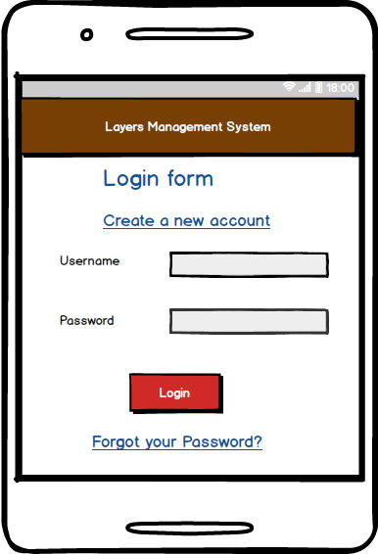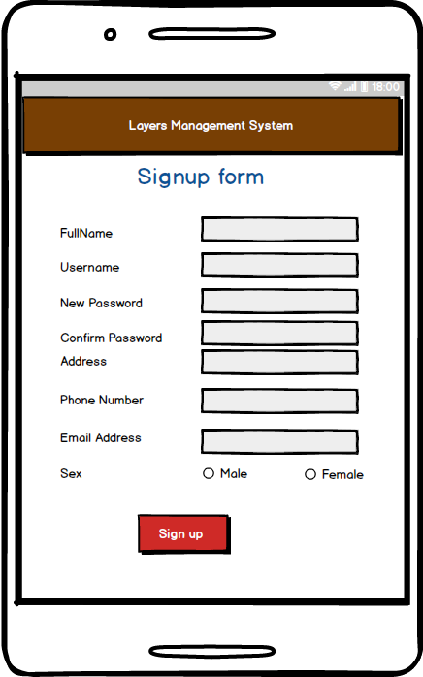

Figure 17 login (left) and sign up (right) pages

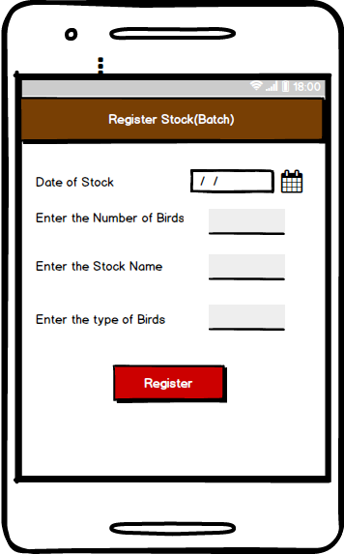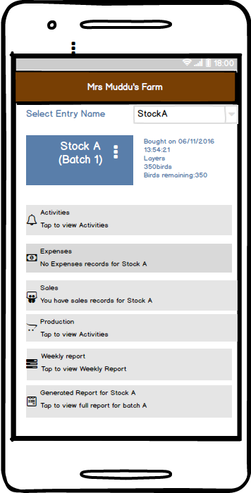

Figure 18 Stock registration (left) and main (right) pages

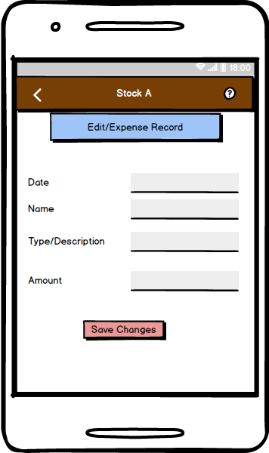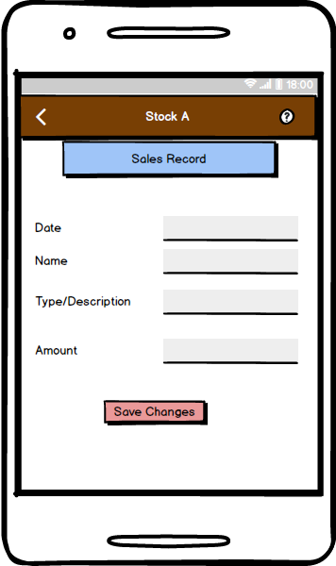

Figure 19 the Expenses (left) and Sales (right) record entry pages.

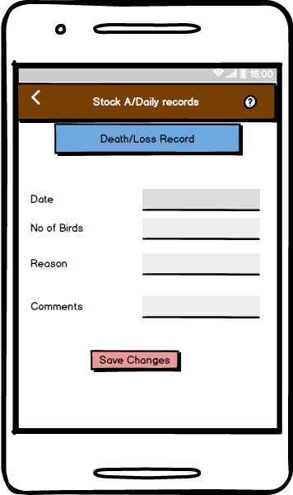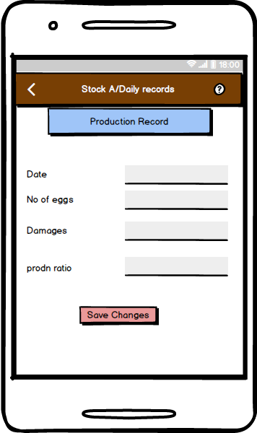

Figure 20 the death/loss (left) and Sales record (right) entry forms

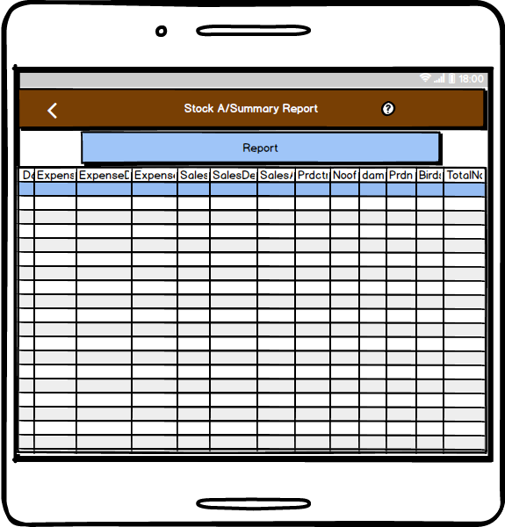

Figure 21 the Generates record view report page

## COMPONENT DESIGN

The **LMS** is divided into four major components which are described below.

Table 9 Component decomposition description

|  |  |  |
| --- | --- | --- |
| **COMPONENTS** | **DESCRIPTION** | **FUNCTION** |
| **Interfaces** | This includes all the user interfaces.  it provides all views reports, forms and buttons | * Displays pages and data to the user. * Enables user to manipulate the system using clicks commands. * Provides fields for data entry |
| **controller** | This interfaces with all other components to as a central component. | * Receives all user commands and directs the necessary actions. * Makes method and requests to the database and Manipulation system. * Returns data to be represented in the interfaces |
| **Manipulation system** | This in the one which has methods which make the calculations involved in the system | * Does calculations * Returns results to method calls. * Handles code exceptions |
| **Online database** | This is the store for the data | * Store the provided data into tables. * Responds to database queries |

## SYSTEM ARCHITECTURE

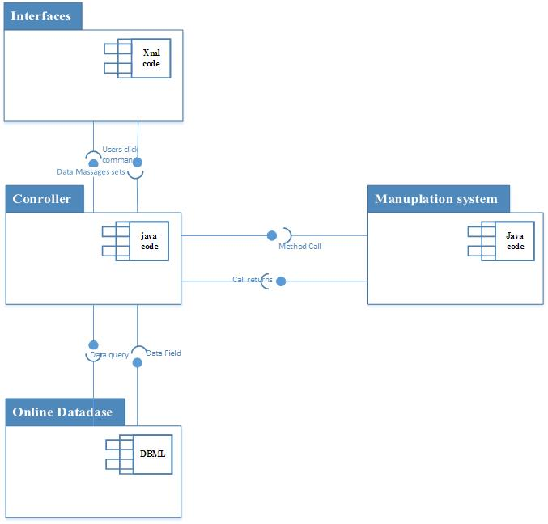

Figure 22 architectural design

## FACTS FINDING METHODS

### QUESTIONNAIRE

As a designing team we decided to find facts through an oral interview based on the following questionnaire.

1. Which type of the birds do you keep?
2. How many birds of this type do you have?
3. How do you group these birds?
4. What factors determine a chicken feed?
5. How do you determine the chance of a feed?
6. How do you obtain these birds?
7. How do you manage the work on your farm? Do you employ some workers?
8. What are the different types of the expenses you incurred on the farm?
9. What products do you sell on your farm?
10. Do you have any other source of revenue if yes, specify?
11. Do you keep records?
12. If yes, who keeps these records?
13. What records do you keep?
14. How do you benefit from keeping records?
15. When do you take a record?
16. How confidential are your records?
17. What would happen if you lose your records?
18. If No, then how do you take note of what happens on your farm?
19. What losses do you suffer?
20. How do you determine your profits?
21. Which of these computing devices would you rather use if you were to have a computerized poultry system?
22. A phone.
23. A lap top computer
24. A desk top computer
25. A tablet
26. An iPad.

## APPENDIX

### Table of acronyms

Table 10 Acronyms

|  |  |
| --- | --- |
| **ABBREVIATION** | **MEANING** |
| **LMS** | Layers Management System |
| **Ref:** | With reference to |
| **FCM** | Fact Collection and Management |
| **RQ** | Requirement |
| **NFR** | Non Functional requirement. |
| **QN** | Questionnaire question |